# Report

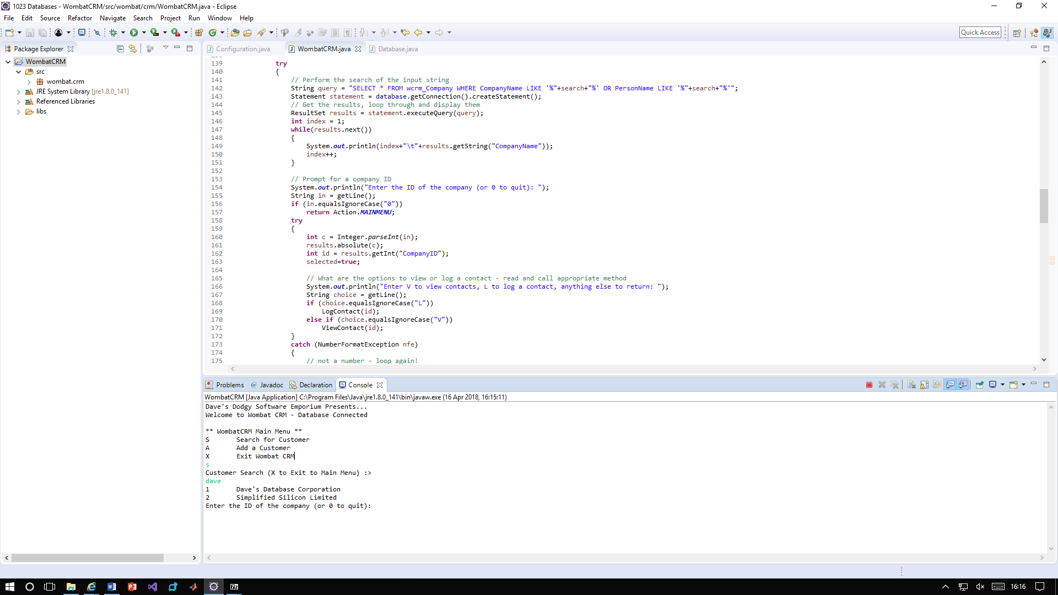

1. As you can see, the program now searches both CompanyName and PersonName for input

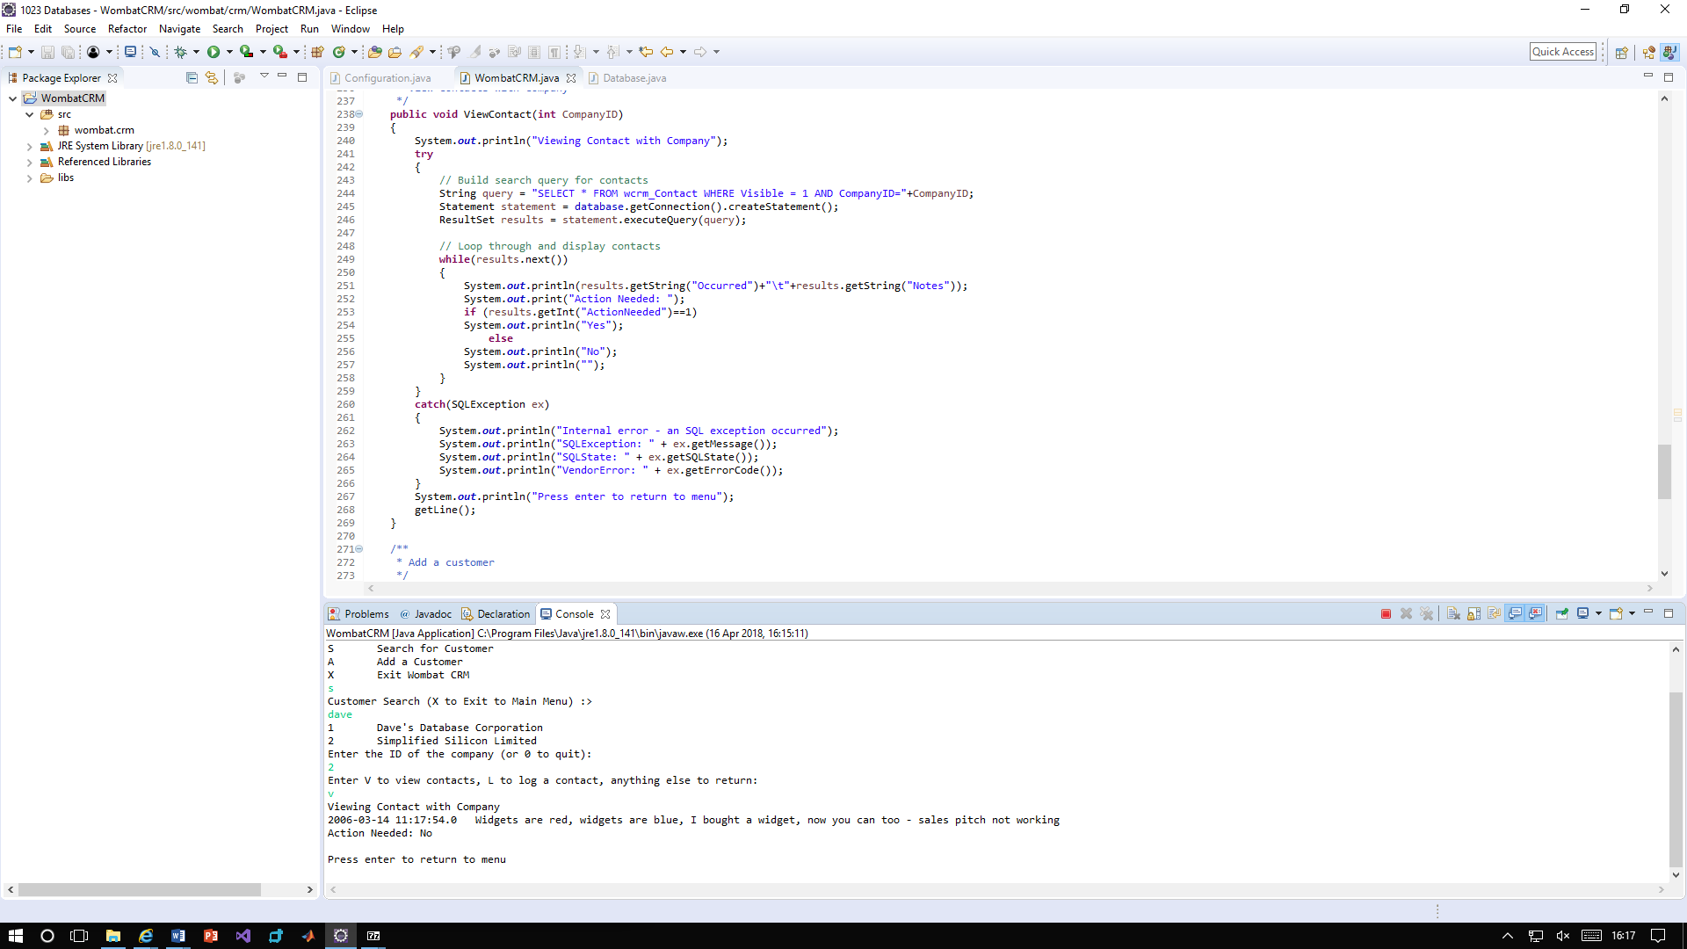

1. Here you can see that only visible records are shown

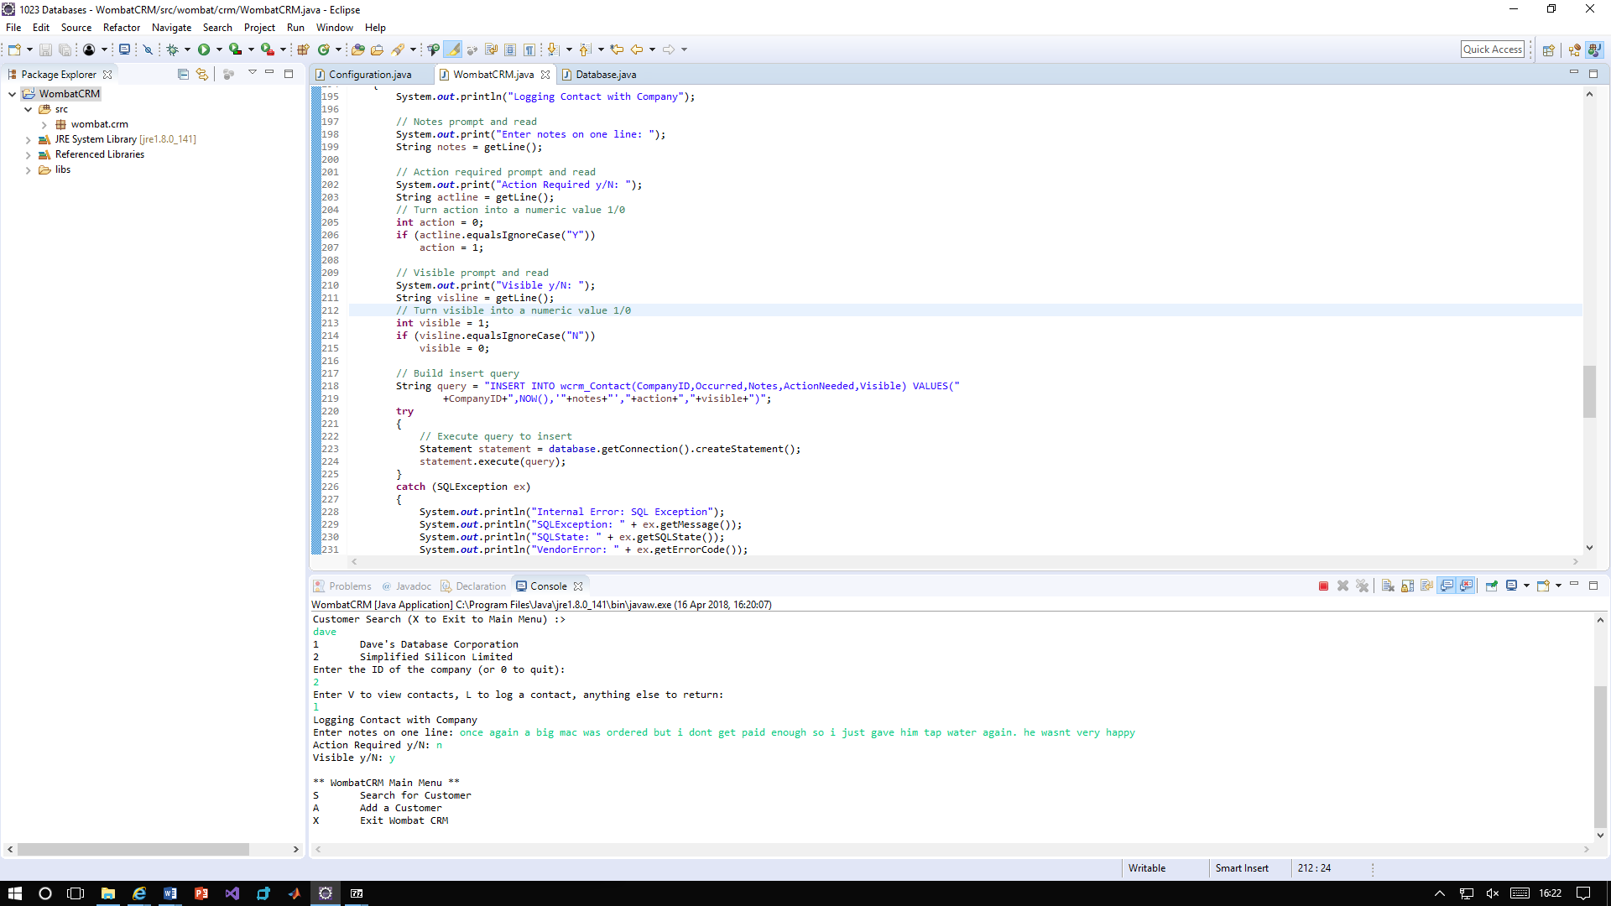

1. As you can see the program asks the user for input on whether it should be visible or not. If there is no input it defaults to 1. Below you will see the new contact in the database.

